Ex. 3 A2 Weather
Name: ____________________________ Surname: ____________________________ N^{ber}: ____ Grade/Class: _____
Assessment: _____________________________ | Date: ___________________________________________________
 | Teacher’s signature:  ___________________________ | Parent’s signature:  ___________________________

Listen and draw lines to match the months with the correct weather photos.

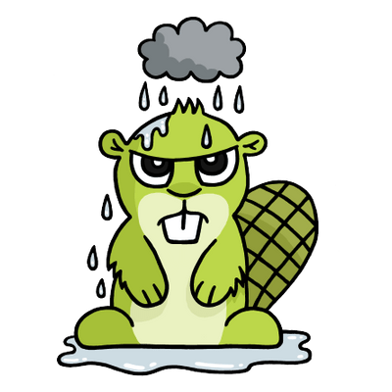

- January 2.March 3.July 4. December

Transcript.
In my country the weather changes during the year. There is different weather for all seasons.
In January, it is usually very cold and we have low temperatures. In March, there are a lot of heavy rains and everything is wet.
In July, the weather is extremely hot and we have heatwaves. In December, we have a lot of snow , we make snowmen and we play with snow balls !!

