Ex. 4 A2 Weather
Name: ____________________________ Surname: ____________________________ N^{ber}: ____ Grade/Class: _____
Assessment: _____________________________ | Date: ___________________________________________________
 | Teacher’s signature:  ___________________________ | Parent’s signature:  ___________________________

Listen and write YES or NO in the following sentences:
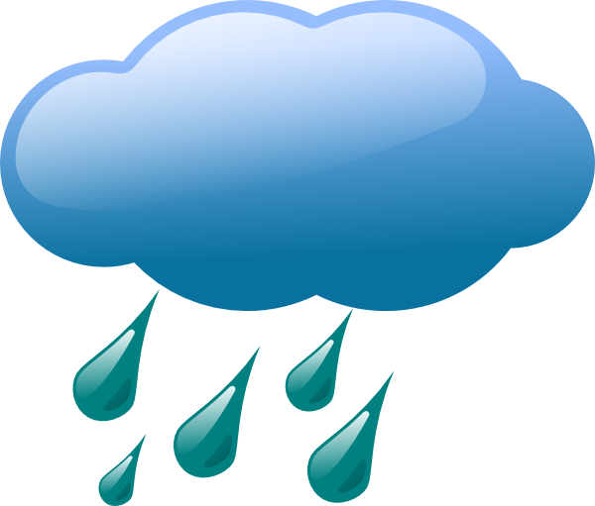 1. In the morning, the weather will be sunny --------
2. Later at midday, it will be rainy and windy ---------
3. In the afternoon, there will be thunderstorms ---------
4. Later at night, it will become dry ----------
5. It will be very cold during the night -----------

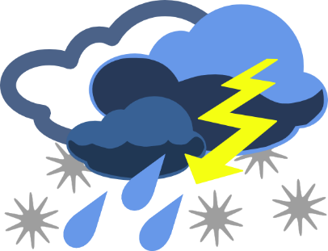

Key: 1.no 2.yes 3.yes 4.no 5.yes

Transcript:
Good morning to you all! Very bad news for the weather in our town today. It will start cloudy at the beginning of the day and will rain heavily later on. The rain will continue all day long together with strong winds.
In the afternoon, there will be thunderstorms and the rain will turn into snow at night. The temperature will drop to 0 degrees Celsius during the night.

