Exercise 5 A2 Weather
Name: ____________________________ Surname: ____________________________ N^{ber}: ____ Grade/Class: _____
Assessment: _____________________________ | Date: ___________________________________________________
 | Teacher’s signature:  ___________________________ | Parent’s signature:  ___________________________

Listen and draw lines from the country to the correct weather
Germany

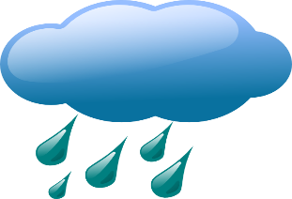
France
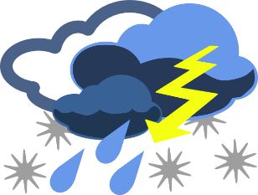 England

Greece

Key: 1. Greece 2. England 3. France 4. Germany

Transcript:
In Greece there will be nice, dry, sunny weather with high temperatures today but it will rain all day long in England.
In France, the weather will be cloudy with thunders and it may rain heavily later on while in Germany it will be freezing cold as it will snow during the whole day

