Exercise 1 A2 Weather
Name: ____________________________ Surname: ____________________________ N^{ber}: ____ Grade/Class: _____
Assessment: _____________________________ | Date: ___________________________________________________
 | Teacher’s signature:  ___________________________ | Parent’s signature:  ___________________________

Read the weather forecast for the Snowdonia National Park for tomorrow and answer the questions.
Mountains can be dangerous places. Always check the weather forecast before you go out.
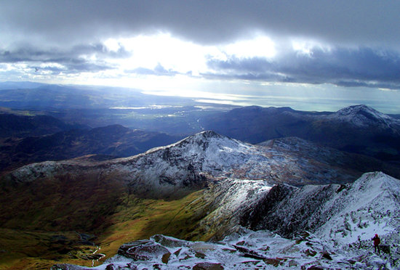
There will be mist and fog in the valleys early on, but this will clear in the morning. It will be a dry day with some sunny spells, especially in the north, where it will feel warm.
It will remain cloudy in the south and west. Cloud will get thicker in the afternoon, and there will be some rain in the west in the late afternoon.
Fill in the gaps with the correct word.
- At the beginning of the day, there will be ------ and -------.
- It will be a ----- day
- It will remain ------- in the south and west
- There will be some -------- in the west in the afternoon.

Key:
1. At the beginning of the day, there will be mist and fog.
2. It will be a dry day
3. It will remain cloudy in the south and west
4. There will be some rain in the west in the afternoon.

