Exercise 2 A2 Weather
Name: ____________________________ Surname: ____________________________ N^{ber}: ____ Grade/Class: _____
Assessment: _____________________________ | Date: ___________________________________________________
 | Teacher’s signature:  ___________________________ | Parent’s signature:  ___________________________
Read the passage and answer the following questions
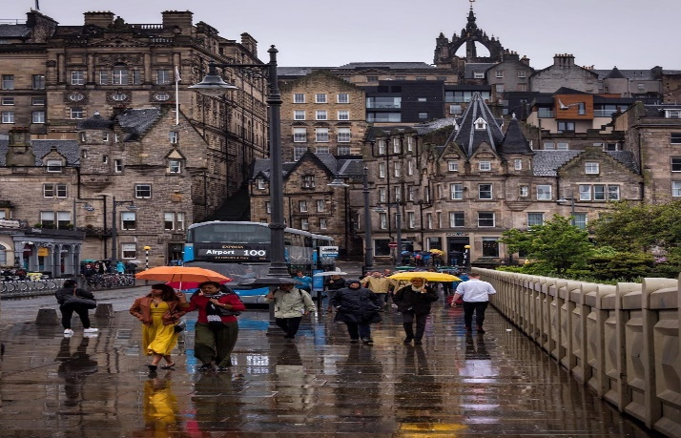
The weather today is very cold. It's just a few degrees above zero right now, and it's probably going to snow. The sky is grey and cloudy.
Yesterday's weather was like today's. It was cold and cloudy, and then it snowed in the afternoon. In the evening, it got really, really cold. After midnight, the temperature was ten degrees below zero.

1. What colour is the sky? It's _______________
2. Was yesterday's weather the same or different? It was _____________
3. What was the weather like yesterday? It was ----------------------
--------------------------------------------------------------------------------------------------------------

Key: 1 grey 2 the same 3 cold , cloudy and snowy

