Ex. 4 A2 Weather
Name: ____________________________ Surname: ____________________________ N^{ber}: ____ Grade/Class: _____
Assessment: _____________________________ | Date: ___________________________________________________
 | Teacher’s signature:  ___________________________ | Parent’s signature:  ___________________________

This is the weather forecast for tomorrow:
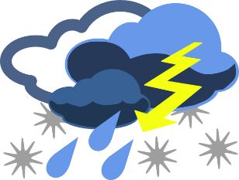
A much windier day, and it will feel cold high up, where temperatures will be low. A bright start, with some sunshine and showers, but rain will increase in the afternoon, and there may be some hail and thunder. Snow showers possible above 800m.

Answer the questions by writing YES or NO

- Will the weather be windy tomorrow? _________
- Will it be hot tomorrow? _________
- Will rain become more in the afternoon? _________
- Will it be foggy tomorrow? _________

Key: 1 yes 2 no 3. Yes 4. no

