Ex .5 A2 Weather
Name: ____________________________ Surname: ____________________________ N^{ber}: ____ Grade/Class: _____
Assessment: _____________________________ | Date: ___________________________________________________
 | Teacher’s signature:  ___________________________ | Parent’s signature:  ___________________________

Read the weather forecast for Thursday and Friday.
Answer the questions with YES or NO
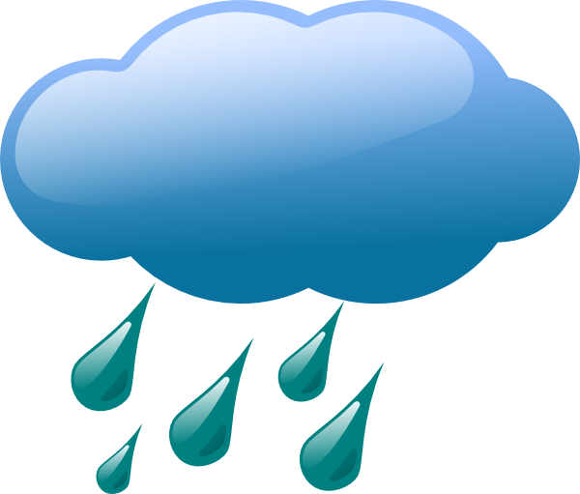
Thursday
Very windy with gales possible in the north and north east. Cloudy with rain or drizzle and hill fog. Some bright spells later, but showers continuing through the afternoon.

Friday
Cloudy at first with areas of hill fog, and also light rain or drizzle. It will gradually become drier and warmer, but will remain cloudy. Light southeasterly breezes.

- On Thursday, it will be windy -----------------
- On Thursday , it will be cloudy -----------------
- On Friday, it will be sunny ------------------
- On Friday, it will snow ------------------

