Ex A2 Weather
Name: ____________________________ Surname: ____________________________ N^{ber}: ____ Grade/Class: _____
Assessment: _____________________________ | Date: ___________________________________________________
 | Teacher’s signature:  ___________________________ | Parent’s signature:  ___________________________

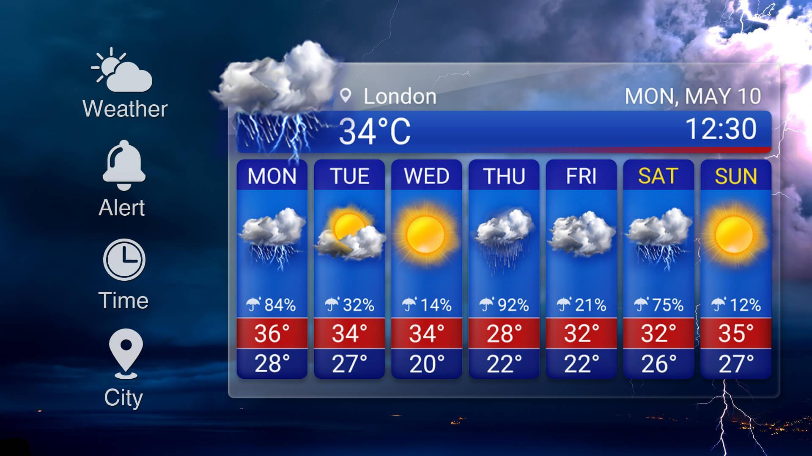

Look at this weather forecast for London for next week.

Can you tell me what the weather will be like each day next week?

For example: It will be rainy with thunderstorms on Monday.
Now you tell me.

