Ex. A 2 Weather
Name: ____________________________ Surname: ____________________________ N^{ber}: ____ Grade/Class: _____
Assessment: _____________________________ | Date: ___________________________________________________
 | Teacher’s signature:  ___________________________ | Parent’s signature:  ___________________________

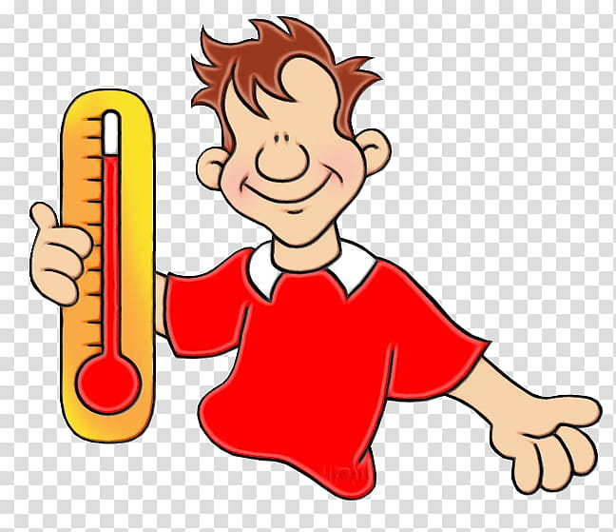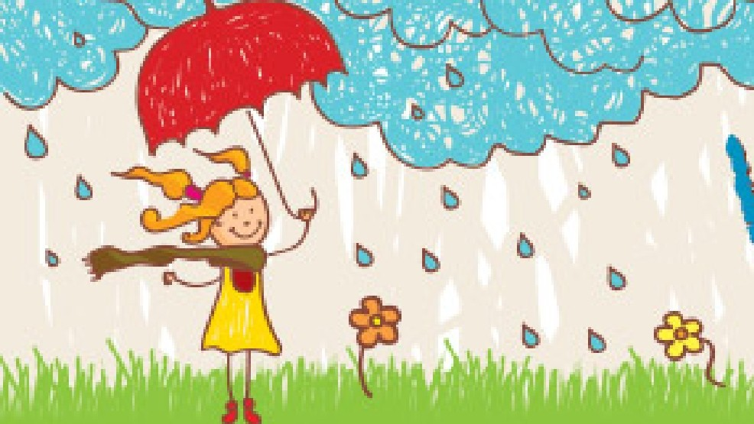

Look at these pictures and tell me how different they are.

For example: The boy in the first picture is happy because the weather is hot.

Now you tell me.

