Exercise A2 Weather
Name: ____________________________ Surname: ____________________________ N^{ber}: ____ Grade/Class: _____
Assessment: _____________________________ | Date: ___________________________________________________
 | Teacher’s signature:  ___________________________ | Parent’s signature:  ___________________________

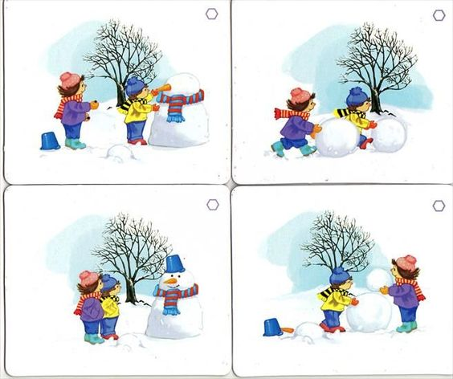

This is a little story about John and Mary. It’s winter and the it is freezing cold.
Can you put the photos in order to tell a story?

