Ex A2 Weather
Name: ____________________________ Surname: ____________________________ N^{ber}: ____ Grade/Class: _____
Assessment: _____________________________ | Date: ___________________________________________________
 | Teacher’s signature:  ___________________________ | Parent’s signature:  ___________________________

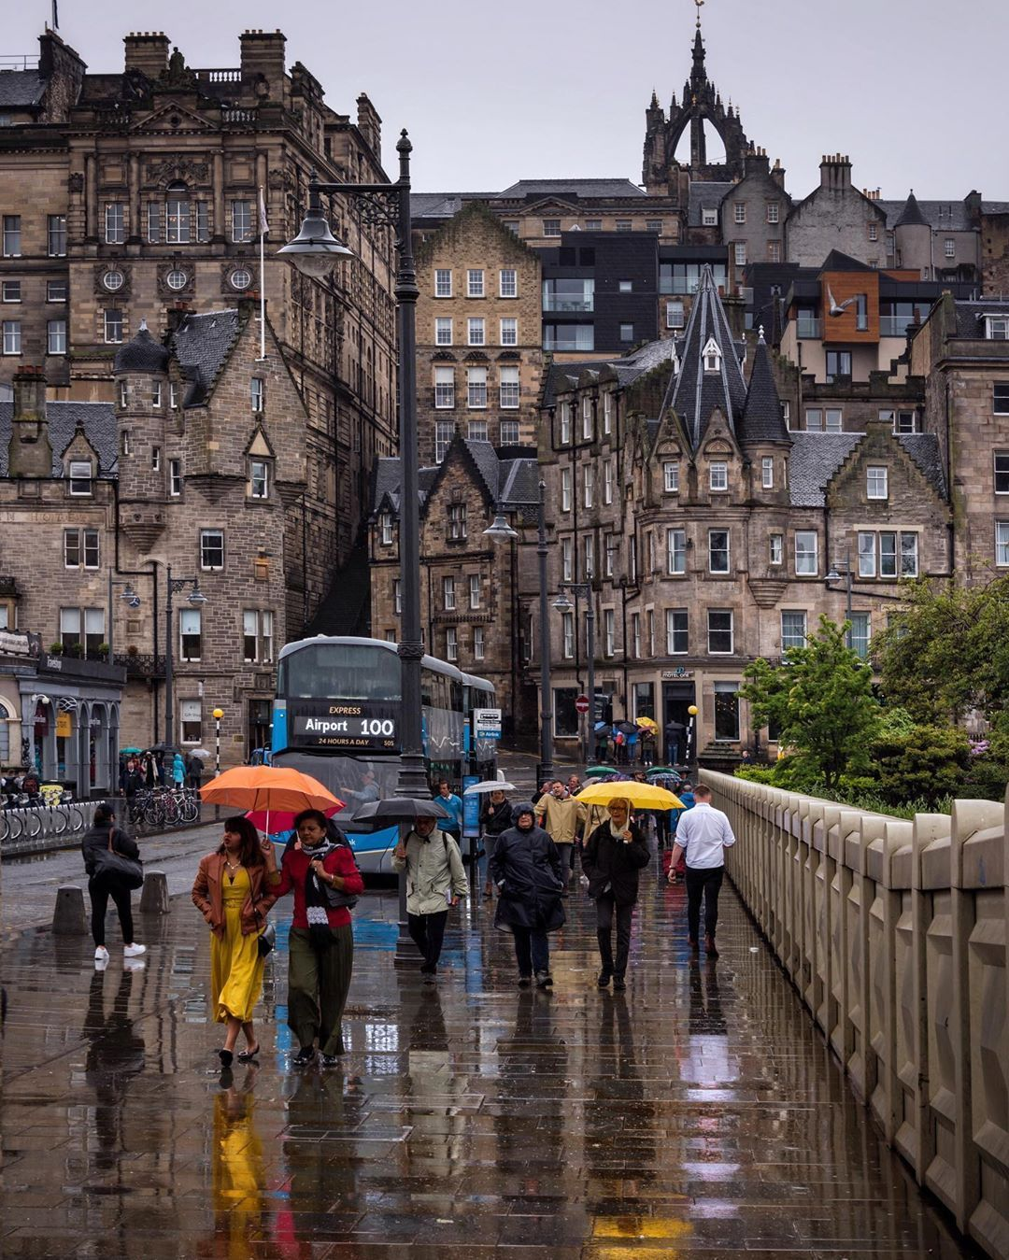
Look at this photo and tell me what you can see.

What is the weather like in this photo?
Do you like this type of weather? Why/Why not?
What is the best weather for you and why?

