Exercise A2 weather
Name: ____________________________ Surname: ____________________________ N^{ber}: ____ Grade/Class: _____
Assessment: _____________________________ | Date: ___________________________________________________
 | Teacher’s signature:  ___________________________ | Parent’s signature:  ___________________________

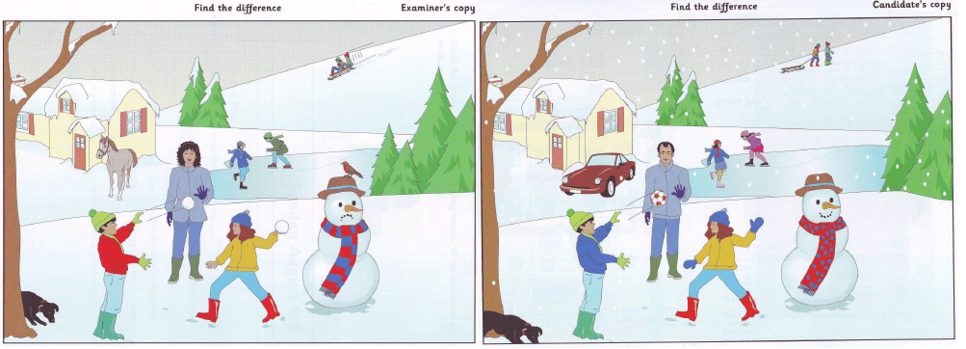

Now here are two pictures. My picture is nearly the same as yours, but some things are different. For example, in my picture there is a horse in front of the house but there isn’t a horse in yours, OK?
I am going to say something about my picture.

In my picture, the girl isn't wearing gloves.
In my picture, the snowman is sad.
In my picture, the boy's jacket is red.

Now you tell me how your picture is different.

