Exercise 1 A2 Weather
Name: ____________________________ Surname: ____________________________ N^{ber}: ____ Grade/Class: _____
Assessment: _____________________________ | Date: ___________________________________________________
 | Teacher’s signature:  ___________________________ | Parent’s signature:  ___________________________

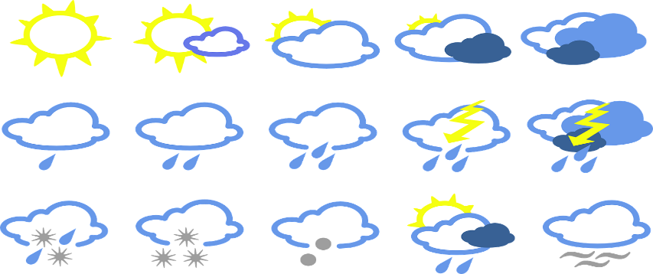

Match the correct weather word to their definition.

1. Cloudy with a completely grey sky (adj) a. shower
2. A noise you can hear in a storm (n) b. drizzle
3. A light, gentle, warm wind (n) c. hail
4. Light and sunny (adj) d. gale
5. A short spell of rain (n) e. thunder
6. Light rain that continues for a long time (n) f. fog
7. Thin, low cloud that often lies in valleys
in the morning (n) g. bright
8. Thick low cloud (n) i. breeze
9. Ice falling from the sky (n) j. overcast
10. A very strong wind (n) k. mist

Key:
1. overcast 2.thunder 3.breeze 4. bright 5. shower 6. Drizzle
7. mist 8. fog 9.hail 10.gale

