Exercise 2 A2 Weather
Name: ____________________________ Surname: ____________________________ N^{ber}: ____ Grade/Class: _____
Assessment: _____________________________ | Date: ___________________________________________________
 | Teacher’s signature:  ___________________________ | Parent’s signature:  ___________________________

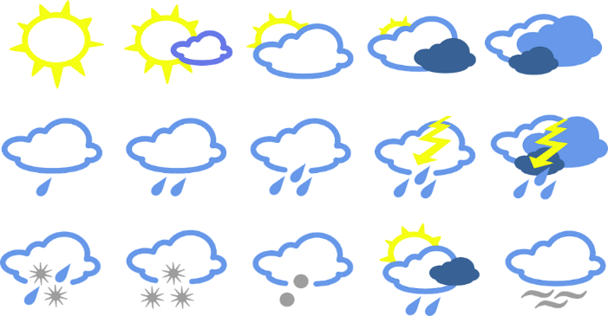
Unscramble the following weather words:

1. yarni = --------------------------
2. nywdi = ---------------------------
3. winraob = ----------------------------
4. nnyus = -----------------------------
5. cydlou = -----------------------------
6. olco = -----------------------------
7. osfrt = -----------------------------
8. torms = ----------------------------
9. dehurtn = ----------------------------
10. nhisnsue = -----------------------------

Key: 1. Rainy 2. Windy 3. Rainbow 4. Sunny 5. Cloudy 6. Cool 7. Frost 8. Storm 9. Thunder 10. Sunshine

