Ex.3 A2 weather
Name: ____________________________ Surname: ____________________________ N^{ber}: ____ Grade/Class: _____
Assessment: _____________________________ | Date: ___________________________________________________
 | Teacher’s signature:  ___________________________ | Parent’s signature:  ___________________________

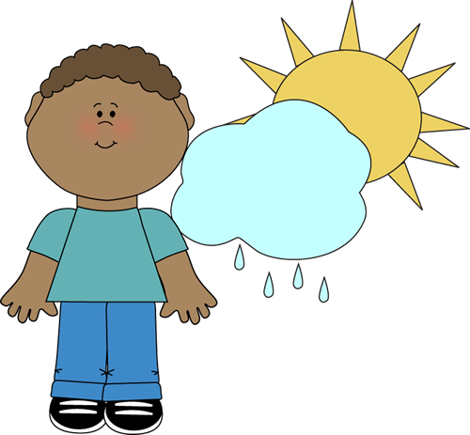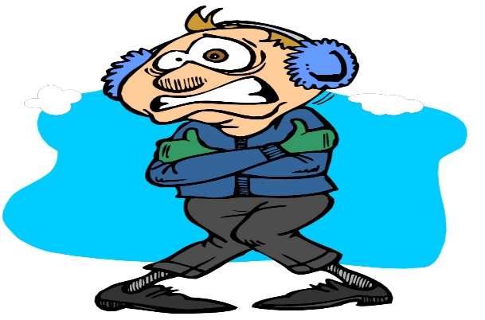
Read about the weather in this country and fill in the gaps with the words from the box.
Weather/hot /snow /cold/play

In my country the weather changes during the year. There is different 1___________ for all seasons.
In January, it is usually very 2.__________ and we have low temperatures. In March, there are a lot of heavy rains and everything is wet.
In July, the weather is extremely 3._______and we have heatwaves. In December, we have a lot of 4.____________, we make snowmen and we 5. _______ with snow balls.

Key
In my country the weather changes during the year. There is different weather for all seasons.
In January, it is usually very cold and we have low temperatures. In March, there are a lot of heavy rains and everything is wet.
In July, the weather is extremely hot and we have heatwaves. In December, we have a lot of snow , we make snowmen and we play with snow balls !!

