Exercise 2 Weather A2
Name: ____________________________ Surname: ____________________________ N^{ber}: ____ Grade/Class: _____
Assessment: _____________________________ | Date: ___________________________________________________
 | Teacher’s signature:  ___________________________ | Parent’s signature:  ___________________________

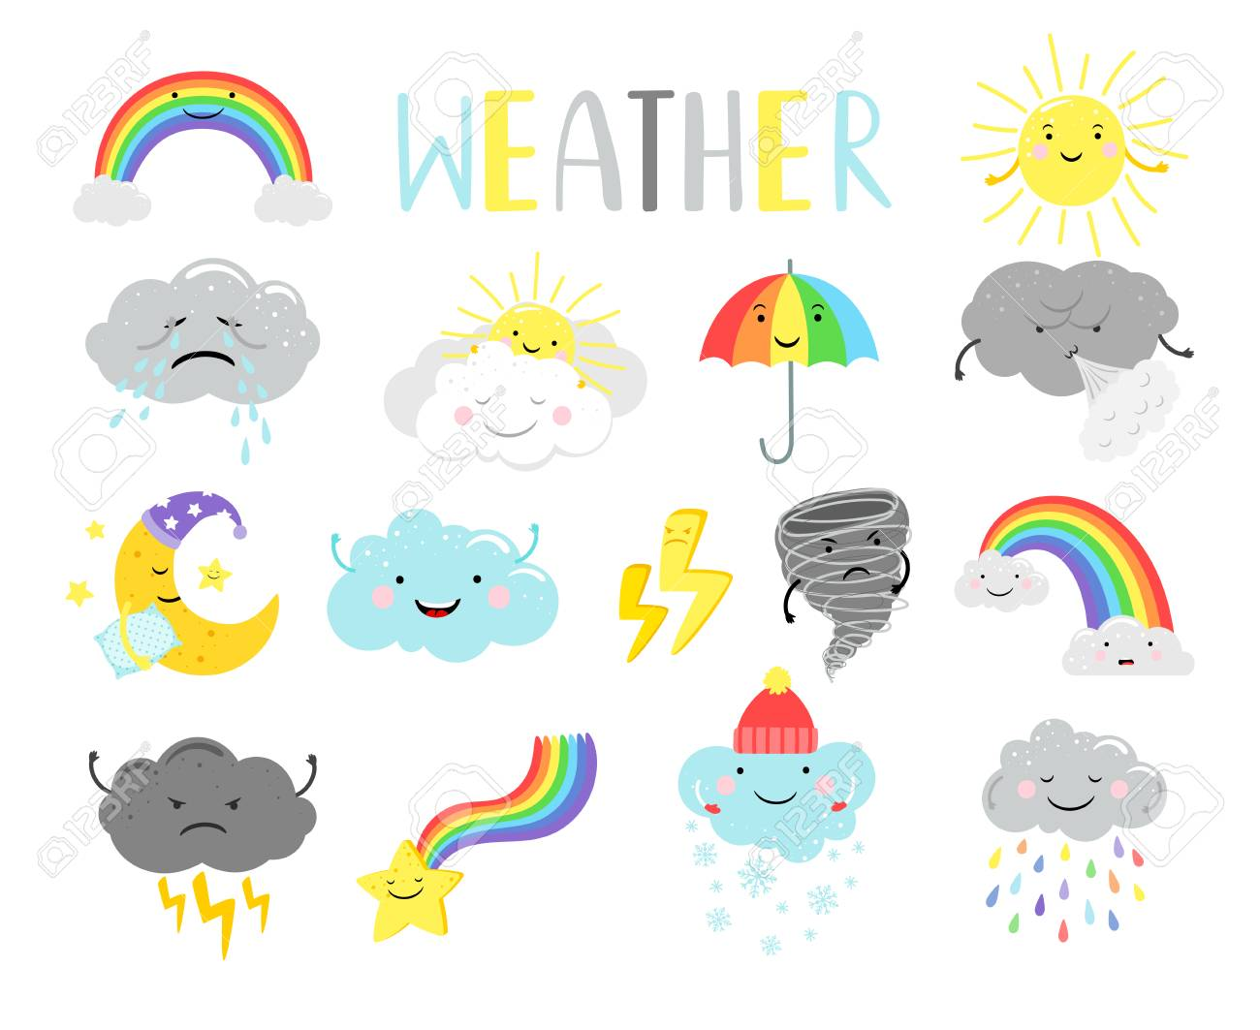
Write 5 words that you can see in the weather symbols and you know about weather: e.g. cloudy
1. --------------------------------------------
2. --------------------------------------------
3. ---------------------------------------------
4. --------------------------------------------
5. --------------------------------------------

