Ex. 2 A2 Weather
Name: ____________________________ Surname: ____________________________ N^{ber}: ____ Grade/Class: _____
Assessment: _____________________________ | Date: ___________________________________________________
 | Teacher’s signature:  ___________________________ | Parent’s signature:  ___________________________
This is the weather forecast of Tokyo, Japan for the next days.
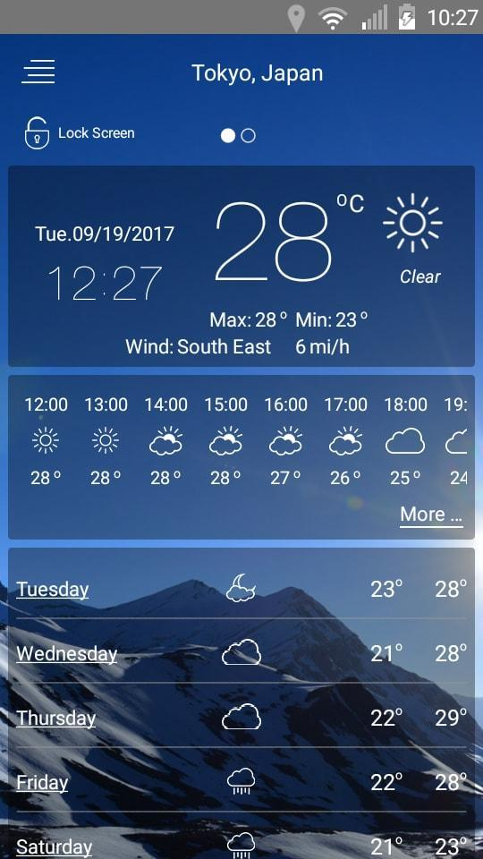
Write what the weather will be like the following days:
On Tuesday -----------------, on Wednesday -----------------------, on Thursday ----------------------,
on Friday------------------------and on Saturday--------------.

