Ex. 4 A2 Weather
Name: ____________________________ Surname: ____________________________ N^{ber}: ____ Grade/Class: _____
Assessment: _____________________________ | Date: ___________________________________________________
 | Teacher’s signature:  ___________________________ | Parent’s signature:  ___________________________

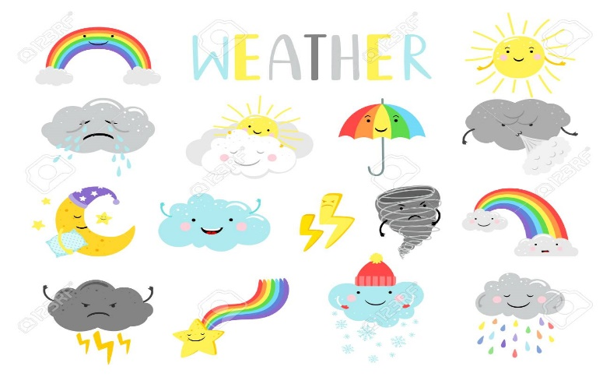
Match the following weather words with the items and clothes you wear:

T-shirt, umbrella, jacket, gloves, anorak, scarf, shorts, winter boots, sunglasses, woolen hat, straw hat, coat

Cold, snowy weather---------------------------------------------------------------------------
Hot, sunny weather -----------------------------------------------------------------------------
Cloudy, rainy and foggy weather -------------------------------------------------------------

