Ex.5 A2 Weather
Name: ____________________________ Surname: ____________________________ N^{ber}: ____ Grade/Class: _____
Assessment: _____________________________ | Date: ___________________________________________________
 | Teacher’s signature:  ___________________________ | Parent’s signature:  ___________________________

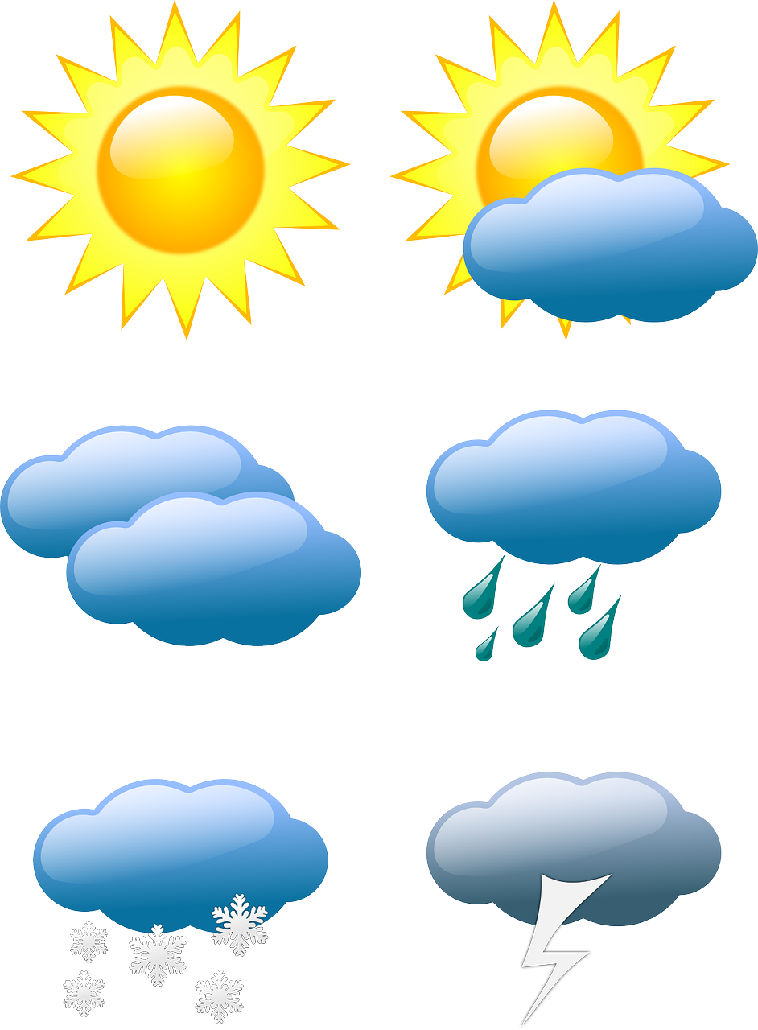
Write 5 different types of weather these symbols show:
- -----------------------------------------------------------
- -----------------------------------------------------------
- -----------------------------------------------------------
- ----------------------------------------------------------
- ----------------------------------------------------------

