Exercise 5 A1 Sports
Name: ____________________________ Surname: ____________________________ N^{ber}: ____ Grade/Class: _____
Assessment: _____________________________ | Date: ___________________________________________________
 | Teacher’s signature:  ___________________________ | Parent’s signature:  ___________________________

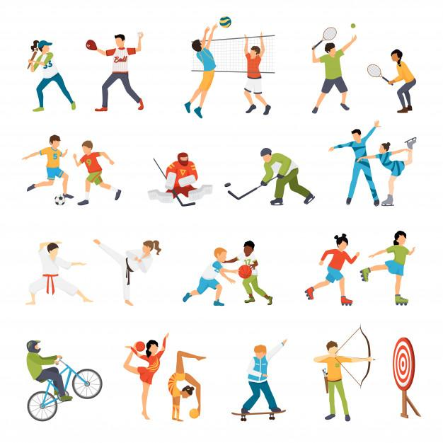
Fill in the missing letters in the following sports words:
1. F_otb_ll
2. R_nn_ng,
3. K_rat_
4. J_do
5. Ba_ket_all
6. Sk_ing
7. Vol-eyba-l
8. T_nn_s
Language (Spelling) - Two points for each correctly spelled answer given (16 Marks)
Excellent: 16-18 🙂👏
Very Good: 13-15 🙂
Satisfactory: 9-12 😐
Unsatisfactory: 5- 8 ☹️
Poor : 0-4 ☹️

KEY
1. Fo_otb_a ll
2. R_u nn i_ng,
3. K_a rat_e
4. J_ u do
5. Ba s_ket_ ball
6. Sk i_ing
7. Vol l-eyba- ll
8. T_e nn_i s

