Ex 5 A1 sports
Name: ____________________________ Surname: ____________________________ N^{ber}: ____ Grade/Class: _____
Assessment: _____________________________ | Date: ___________________________________________________
 | Teacher’s signature:  ___________________________ | Parent’s signature:  ___________________________

1.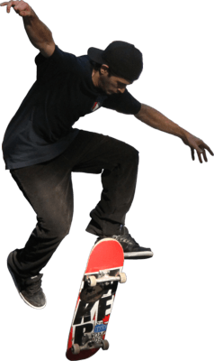2. 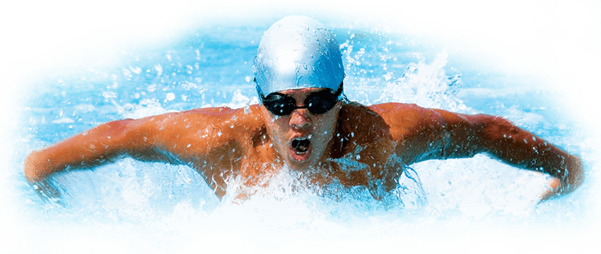
3.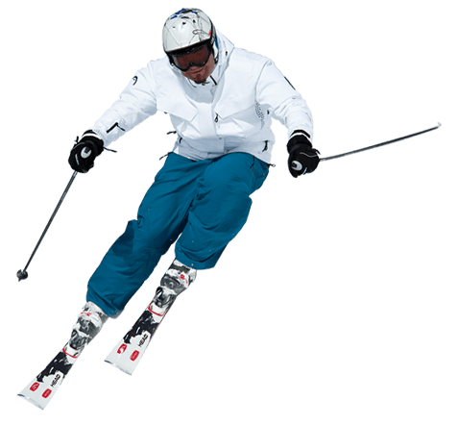4.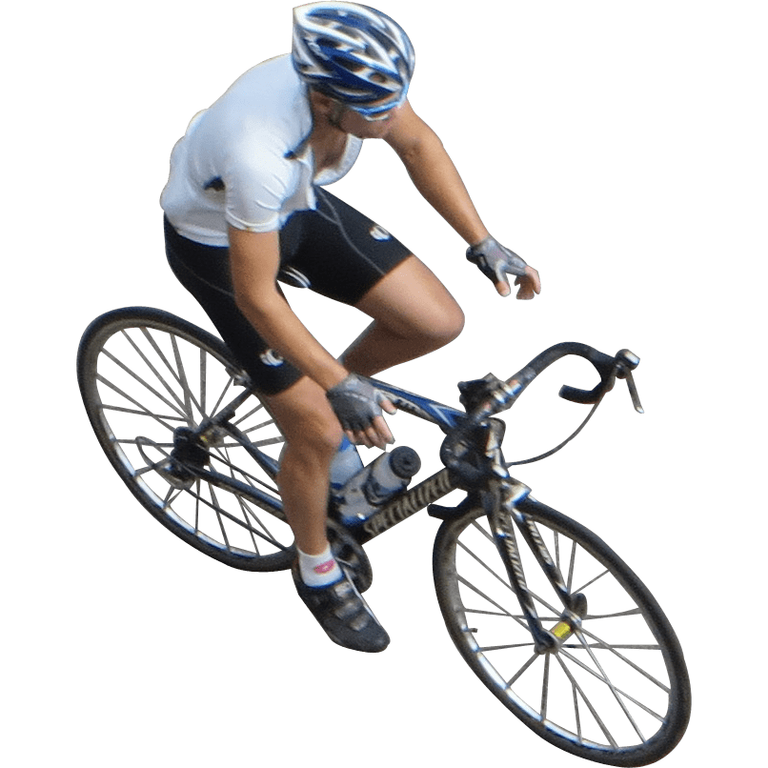

Write the name of these 4 sports shown in the pictures:

- ------------------------------------- 2. ---------------------------------------

3. ------------------------------------- 4. ------------------------------------

Marking Scheme 16 Marks
Task Achievement - Two points for each answer given total 8 marks
Excellent: 7-8 🙂👏
Very Good: 5-6 🙂
Satisfactory: 4-5 😐
Unsatisfactory: 2-3 ☹️
Poor: 0-1 ☹️
Language (Spelling) - Two points for each correctly spelled answer given 8 Marks
Excellent: 7-8 🙂👏
Very Good: 5-6 🙂
Satisfactory: 4-5 😐
Unsatisfactory: 2- 3 ☹️
Poor: 0-1 ☹️

14-16 Excellent 11- 13: Very Good 8- 10: Satisfactory 5- 7: Unsatisfactory 1- 4: Poor

KEY
Skateboarding, swimming, cycling, skiing

