Ex. 2 A1 Weather
Name: ____________________________ Surname: ____________________________ N^{ber}: ____ Grade/Class: _____
Assessment: _____________________________ | Date: ___________________________________________________
 | Teacher’s signature:  ___________________________ | Parent’s signature:  ___________________________

Write the correct words next to weather symbols

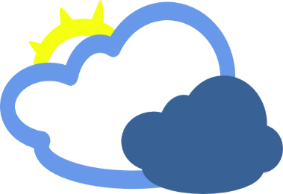 C - - - - Y
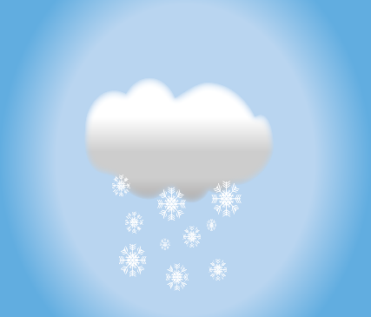 S - - - Y

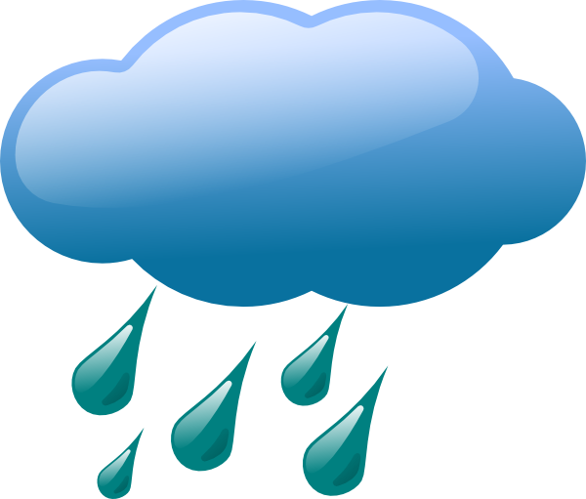 R - - - Y

Marking scheme 6 marks
2 POINTS FOR EACH CORRECT ANSWER (SPELLING)

Excellent: 5-6 🙂👏
Very Good: 3-4 🙂
Needs Improvement: 0-2 😐

KEY
CLOUDY / SNOWY/ RAINY

