Ex.4 A1 Weather
Name: ____________________________ Surname: ____________________________ N^{ber}: ____ Grade/Class: _____
Assessment: _____________________________ | Date: ___________________________________________________
 | Teacher’s signature:  ___________________________ | Parent’s signature:  ___________________________

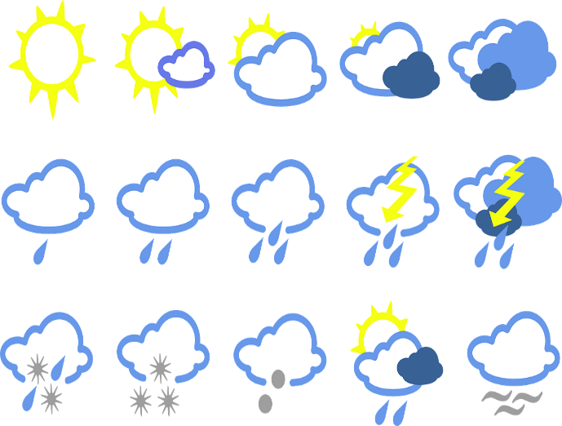
What is the weather like in your country?
Use the following words and write about the weather in your country in different seasons.

sunny, cloudy, rainy, foggy, snowy, very hot, cool, very cold, thunderstorms, windy, dry, wet

In winter --------------------------------------------------
In spring --------------------------------------------------
In summer-----------------------------------------------
In autumn------------------------------------------------

3 points for each correct answer total 12 marks
Task Achievement - three points for each correct answer given (12 Marks)
Excellent: 11-12 🙂👏
Very Good: 8-10 🙂
Satisfactory: 5-7 😐
Unsatisfactory: 3-4 ☹️
Poor: 0-2 ☹️

KEY
In winter: cloudy/ rainy /foggy/snowy/ very cold/ thunderstorms/ windy/wet
In spring: cloudy/ rainy /foggy/ windy/wet/cool/ sunny
In summer: sunny/ dry/very hot/ cloudy /windy
In autumn: cloudy/ rainy /foggy/ windy/wet/cool/ sunny

