Ex. 5 A1 Weather
Name: ____________________________ Surname: ____________________________ N^{ber}: ____ Grade/Class: _____
Assessment: _____________________________ | Date: ___________________________________________________
 | Teacher’s signature:  ___________________________ | Parent’s signature:  ___________________________

Answer the following questions:
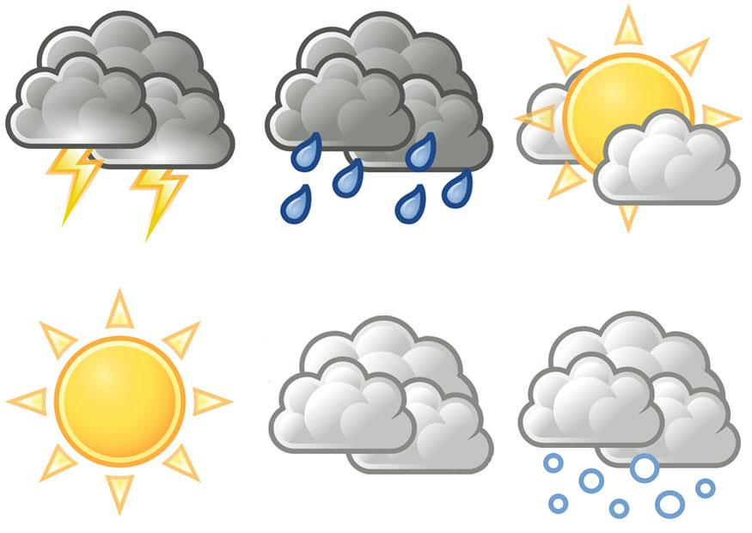

Which weather do you like the most?

Which weather do you dislike the most?

-----------------------------------------------------------------------------------------------------------------------------------------------------------
-

MARKING SCALE 20 marks
Task Achievement 10 Marks
Excellent: 9-10 🙂👏
Considerable variety of ideas, relevant to assigned topic, valid ideas organized clearly
Very Good: 7-8🙂
Most content points elaborated, relevant to assigned topic, valid ideas organized clearly.
Satisfactory:5-6 😐
Some valid ideas,somewhat choppy but main ideas stand out
Unsatisfactory: 3-4 ☹️
Limited variety of ideas, hardly any content points elaborated, main ideas not always clear.
Poor : 0-2 ☹️
Insufficient treatment of topic, ideas often confused or disconnected.

Language (Grammar and Vocabulary) 10 Marks
Excellent: 8-10🙂👏
Wide range of appropriate vocabulary and structures ambitious attempts at complex language. Hardly any spelling errors.
Very Good: 5-7🙂
Good range of appropriate vocabulary and structures. Language is generally accurate, a few spelling errors.
Satisfactory: 3-4😐
Adequate range of language chunks and vocabulary. A number of spelling errors may be present but they do not impede communication.
Unsatisfactory: 1- 3☹️
Limited range of vocabulary. Spelling errors may obscure communication at times
Poor: ☹️ 0-2
Narrow, inadequate vocabulary, Illegible writing. A considerable number of errors which impede communication

