Name: ____________________________ Surname: ____________________________ N^{ber}: ____ Grade/Class: _____
Assessment: _____________________________ | Date: ___________________________________________________
 | Teacher’s signature:  ___________________________ | Parent’s signature:  ___________________________
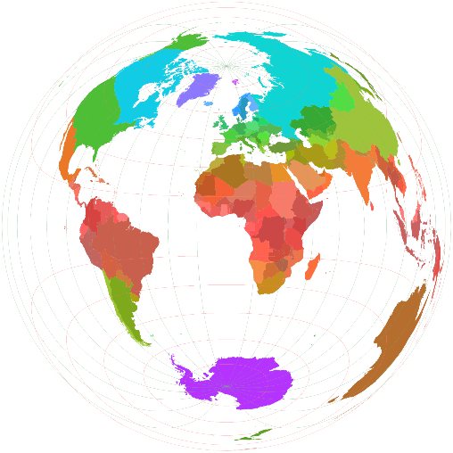
Write a short text about your country. Answer the following questions:
- What country do you live in?
- What city do you live in?
- What is the capital of your country?
- Write about some special things that you have in your city and your country.
- What color is the flag of your country?
- How many people live in your country?
- Which countries are your neighbors?
- Do you have beaches in your country?
- What is the favorite thing about your country?

________________________________________________________________________________
________________________________________________________________________________
________________________________________________________________________________
________________________________________________________________________________
________________________________________________________________________________
________________________________________________________________________________
________________________________________________________________________________
________________________________________________________________________________
________________________________________________________________________________
________________________________________________________________________________
________________________________________________________________________________
________________________________________________________________________________

