Name: ____________________________ Surname: ____________________________ N^{ber}: ____ Grade/Class: _____
Assessment: _____________________________ | Date: ___________________________________________________
 | Teacher’s signature:  ___________________________ | Parent’s signature:  ___________________________
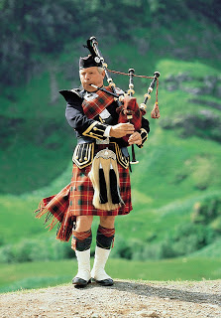
Match the two sections and write the full sentence.

Finland is a country
In Greece you can
In Scotland you can
In Spain you can
Portugal’s capital
The capital of Germany
The country of Italy
Turkey is famous

looks like a boot
visit the Acropolis
in northern Europe
is Lisbon
see flamenco dancers
is Berlin
listen to bagpipes
for their kebab
- ______________________________________________________________________

- ______________________________________________________________________

- ______________________________________________________________________

- ______________________________________________________________________

- ______________________________________________________________________

- ______________________________________________________________________

- ______________________________________________________________________

- ______________________________________________________________________

